**Editing now:**

**4-Chlorothieno[3,2-d]pyrimidine OSM-S-70, (AT-1-2)**



Thieno[3,2-*d*]pyrimidin-4(1*H*)-one (MNR 89-1) (1.57 g, 10.3 mmol, 1.0 equiv.) was stirred under an atmosphere of Ar. Phosphorus(V) oxychloride (15.8 g, 9.58 mL, 103 mmol, 10.0 equiv.) was added and the reaction mixture stirred at reflux for 3 h under the inert atmosphere. The reaction mixture was allowed to cool to rt and then added dropwise to an ice/water slurry (~100 mL) with stirring. A saturated aqueous solution of NaHCO3 (~200 mL) was added slowly with stirring, followed by solid NaHCO3 (~10 g). The aqueous phase was extracted with ethyl acetate (4 × 100 mL) and the combined organic extracts were dried (MgSO4), filtered and concentrated under reduced pressure to give the product as an off-white solid which was purified by filtration through a short bed of silica (1:1 EtOAc/hexanes) to give the product as a white solid (1.69 g, 96%); **m.p.** 124–126 °C (lit{98] 123–124 °C); **1H NMR** (400 MHz, CDCl3): δ 7.61 (1H, d, *J* 5.9), 8.05 (1H, d, *J* 5.9), 9.00 (1H, s); m/z (APCI+) 171.0 (100%, MH+), 172.9 (35%, MH+).

Data consistent with literature. (99).

*InChI=1S/C6H3ClN2S/c7-6-5-4(1-2-10-5)8-3-9-6/h1-3H*

<http://malaria.ourexperiment.org/uri/27c>

98. Song, Y.-H., A facile synthesis of new 4-(phenylamino)thieno[3,2-*d*]pyrimidines using 3-aminothiophene-2-carboxamide. *Heterocycl. Commun.* **2007,** *13*, 33-34.

99. Ham, Y. J.; Lee, D.-H.; Choi, H. G.; Hah, J.-M.; Sim, T., The efficient one-step chlorination of methylsulfanyl group on pyrimidine ring system with sulfuryl chloride. *Tetrahedron Lett.* **2010,** *51* (35), 4609-4611.

**4-Phenylthieno[3,2-d]pyrimidine OSM-S-118, AT-2-x**

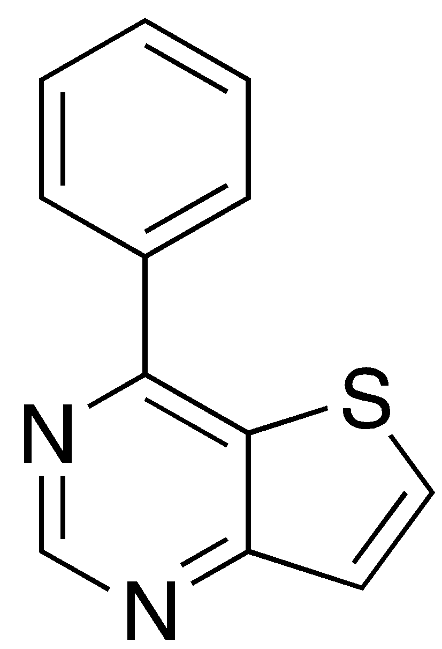

AT-1 (0.200 g, 1.2 mmol, 1.0 equiv.), phenylboronic acid (0.180 g, 1.5 mmol, 1.25 equiv.), cesium carbonate (0.576 g, 1.8 mmol, 1.5 equiv.) and Pd(PPh3)4 (0.068 g, 0.06 mmol, 0.05 equiv.) were combined under argon. Toluene (12 mL) and EtOH (2 mL) were added. The reaction mixture was degassed and stirred under argon at 80ºC for 4 hours. The reaction mixture was cooled to room temperature, diluted with water (40 mL) and extracted into EtOAc (3 × 45 mL). The combined organic layers were dried (MgSO4) and concentrated. The crude product was purified by flash column chromatography over silica (2:1 hexane:EtOAc) to provide the title compound as a white solid (0.232 g, 1.1 mmol, 93%).

1H NMR (400 MHz, CDCl3): δ 7.56 – 7.61 (3H, m), 7.62 (1H, d, J 7.5), 8.02 (1H, d, J 7.5), 8.18 – 8.19 (2H, m), 9.29 (1H, s).

13C NMR (100 MHz, CDCl3): δ 125.1, 128.2, 128.6, 129.2, 131.2, 136.3, 137.4, 155.0, 160.2, 162.2.

m/z (APCI+) 213.1 (100%, MH+).

**6-Bromo-4-phenylthieno[3,2-d]pyrimidine OSM-S-120, AT-4a**

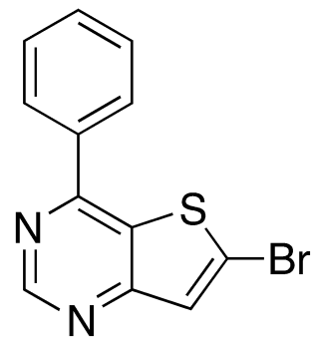

AT-2 (0.100 g, 0.47 mmol, 1 equiv.) was dissolved in THF (10 mL) and cooled to -78ºC.

*N*-BuLi (2.5 M in hexane, 0.4 mL, 0.9 mmol, 2 equiv.) was added dropwise with stirring. The reaction mixture was stirred for 5 minutes at -78  C and bromine (0.302 g, 0.10 mL, 1.9 mmol, 4 equiv.) was added dropwise. The reaction mixture was warmed to room temperature, stirred for 15 minutes and quenched with aqueous Na2S2O3 (10 mL). The mixture was diluted with EtOAc (10 mL) and extracted into EtOAc (2 x 10  mL). The combined organic layers were washed with water (20 mL), brine (20 mL), dried (MgSO4) and concentrated under reduced pressure. The crude product was purified by flash column chromatography over silica (7:1 hexane:EtOAc)to provide the title compound as a *colour* solid (0.078 g,  0.27 mmol, 57%).

1H NMR (400 MHz, CDCl3): δ 7.60 – 7.61 (3H, m), 8.10 – 8.11 (2H, m), 9.34 (1H, s).

m/z (APCI+) 291.0 (100%, MH+), 293.0 (100%, MH+).

**6,7-Dibromo-4-phenylthieno[3,2-d]pyrimidine, OSM-S-119, (AT-4b)**

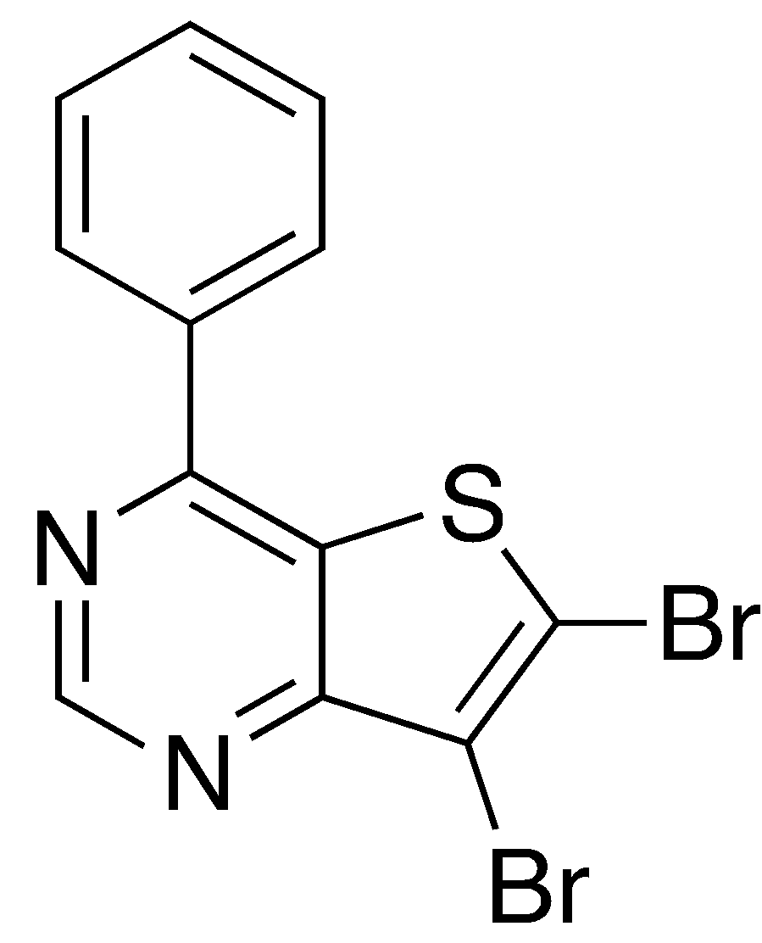

AT-2 (0.100 g, 0.47 mmol, 1 equiv.) was dissolved in THF (10 mL) and cooled to -78ºC.

*N*-BuLi (2.5 M in hexane, 0.4 mL, 0.9 mmol, 2 equiv.) was added dropwise with stirring. The reaction mixture was stirred for 5 minutes at -78°C and bromine (0.097 mL, 1.9 mmol, 4 equiv.) was added dropwise. The reaction mixture was warmed to room temperature, stirred for 15 minutes and quenched with aqueous Na2S2O3 (10 mL). The mixture was diluted with EtOAc (10 mL) and extracted into EtOAc (2 × 10  mL). The combined organic layers were washed with water (20 mL), brine (20 mL), dried (MgSO4) and concentrated under reduced pressure. The crude product was purified by flash column chromatography over silica (7:1 hexane:EtOAc) to provide the title compound as a *colour* solid (0.030 g,  0.08 mmol, 17%).

1H NMR (400 MHz, CDCl3): δ 7.59 – 7.60 (3H, m), 7.64 (1H, s), 8.11 – 8.12 (2H, m), 9.23 (1H, s).

13C NMR (100 MHz, CDCl3): δ 114.6, 126.6, 128.5, 129.1, 129.5, 131.8, 136.4, 156.3, 158.4, 159.4.

m/z (APCI+) 369.1 (50%, MH+), 371.0 (100%, MH+), 373.0 (55%, MH+).

**6-Bromo-4-chloro[3,2-d]pyrimidine (AT-5)**

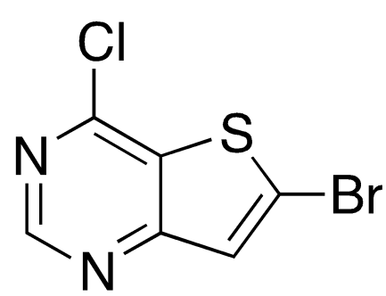

4-Chlorothieno[3,2-*d*]pyrimidine **(**AT-1) (2.10 g, 12.3 mmol, 1.0 equiv.) was dissolved in THF (120 mL) and cooled to -78°C. *n*-BuLi (2.5 M in THF, 7.38 mL, 18.5 mmol, 1.5 equiv.) was added dropwise and the reaction mixture stirred for 30 minutes at 78°C. Bromine (1.26 mL, 24.6 mmol, 2.0 equiv.) was added dropwise. The reaction mixture was warmed to room temperature and stirred for 1 hour. The reaction mixture was quenched with aqueous Na2S2O3 (150 mL) and extracted into EtOAc (3× 100 mL). The combined organic layers were dried (MgSO4) and concentrated under reduced pressure. The crude product was purified by flash column chromatography over silica (7:1 hexane:EtOAc) to provide the title compound as an off-white solid (1.86 g, 7.5 mmol, 61%).

m.p: 135 °C – 136 °C. 1H NMR (400 MHz, CDCl3): δ 7.62 (1H, s), 8.93 (1H, s). 13C NMR (100 MHz, CDCl3): δ 128.0, 129.0, 132.7, 153.4, 155.0, 161.7. IR (film): *v*max/cm-1 1552, 1514, 1426, 1360, 1302, 976. LRMS (APCI): *m/z* 249.1 ([MH]+, (35Cl, 79Br), 65%), 250.9 ([MH]+, (35Cl, 81Br)/(37Cl, 79Br), 100%), 253.1 ([MH]+, (37Cl, 81Br), 25%). HRMS (ESI+): *m/z* calcd. for ([MH]+, (35Cl, 79Br)) 248.88888, ([MH]+, (35Cl, 81Br)/(37Cl, 79Br)) 250.88684, ([MH]+, (37Cl, 81Br)) 252.88389, found 248.88834, 250.88617, 252.88332.

**6-Bromothieno[3,2-d]pyrimidin-4-amine (AT-6)**

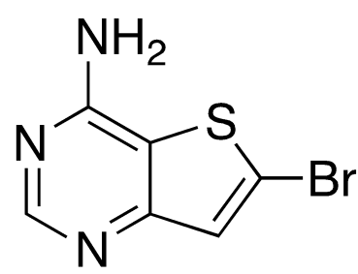

4-Chlorothieno[3,2-*d*]pyrimidine (143 mg, 0.84 mmol, 1.0 eq) and 28 % aq NH4OH (5.0 mL, 14.8 M, 74 mmol, 87 eq) were heated at 120 °C for 3 h in a sealed tube. To the solution was added MeOH (5 mL). The solution was concentrated *in vacuo* to yield a yellow solid. EtOAc (30 mL) and H2O (10 mL) were added to the yellow solid. The organic layer was separated, washed with H2O (10 mL) and brine (10 mL), dried over MgSO4 and concd *in vacuo* to yield the title compound as a yellow solid (83 mg, 0.36 mmol, 43%).

Decomposes at 243 – 245 °C, mp (residual solid): 250 °C – 252 °C. 1H NMR (400 MHz, CH3OD): δ 7.40 (1H, s, H7), 8.33 (1H, s, H2), (H4’ not observed).13C-NMR (100 MHz, CH3OD): δ 117.6 (C6), 125.0 (C4a), 128.0 (C7), 156.0 (C7a), 158.9 (C2), 160.0 (C4). IR (film): *v*max/cm-1 3150, 1676, 1578, 1533, 1514, 822. LRMS (APCI): *m/z* 230.0 ([MH]+, 79Br, 98%), 232.0 ([MH]+, 81Br, 100%). HRMS (ESI+): *m/z* calcd. for ([MH]+, 79Br) 229.93876, ([MH]+, 81Br) 231.93671, found 229.93813, 231.93604. Anal calcd for C6H4BrN3S: C, 31.32; H, 1.75; N, 18.26, found: C, 31.58; H, 1.82; N, 17.99.

**4-6-Diphenylthieno[3,2-d]pyrimidine (AT-7)**

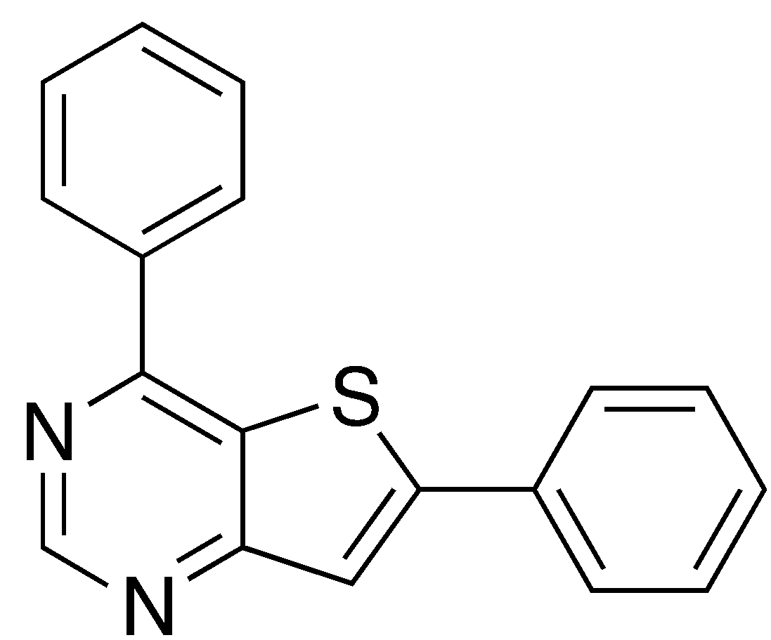

AT-4a (0.025 g, 0.085 mmol, 1 equiv.) and phenylboric acid (0.013 g, 0.10 mmol, 1.2 equiv.) was added to a degassed solution of isopropanol (1 mL) and K2CO3 (1 M, 0.24 mL, 3 equiv.). The reaction mixture was degassed for a further 5 minutes. Pd(dppf)Cl2 (0.012 g, 0.017 mmol, 0.2 equiv.) was added and the reaction mixture stirred at 80°C overnight. The reaction mixture was cooled to room temperature, diluted with EtOAc (20 mL) and filtered through Celite. The organic layer was concentrated under reduced pressure. The crude product was purified by flash column chromatography over silica (6:1 hexane:EtOAc) to provide the title compound as a white solid (0.019 g, 0.065 mmol, 76%).

1H NMR (400 MHz, CDCl3): δ 7.47 – 7.52 (3H, m), 7.58 – 7.63 (3H, m), 7.80 (1H, s), 7.81 – 7.83 (2H, m), 8.22 – 8.24 (2H, m), 9.26 (1H, s).

13C NMR (100 MHz, CDCl3): δ 120.1, 127.0, 128.3, 128.6, 1292, 129.5, 130.3, 131.2, 132.9, 137.4, 154.3, 155.4, 159.5, 163.1.

m/z (APCI+) 289.1 (100%, MH+)

**4-Chloro-6-phenylthieno[3,2-d]pyrimidine (AT-8)**

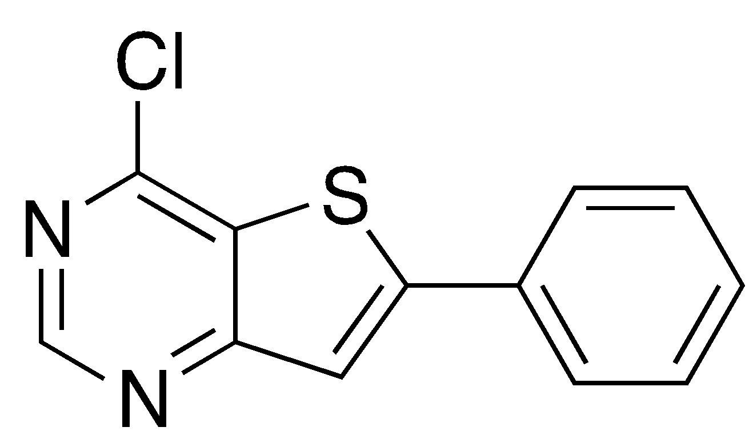

1H NMR (400 MHz, CDCl3): δ 7.50 – 7.53 (3H, m), 7.75 (1H, s), 7.77 – 7.79 (2H, m), 8.97 (1H, s).

m/z (APCI+) 247.1 (100%, MH+), 249.0 (35%, MH+).

**6-Phenylthieno[3,2-d]pyrimidin-4-amine (AT-9)**

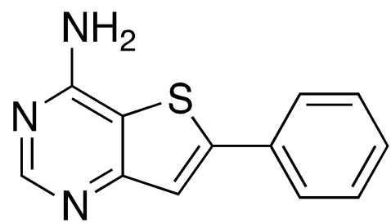

1H NMR (500 MHz, CD3OD): δ 7.44 – 7.47 (1H, m), 7.50 (2H, t, J 7.4), 7.60 (1H, s), 7.82 (2H, d, J 7.4), 8.37 (1H, s).

m/z (APCI+) 228.1 (100%, MH+)

**4-(4-Aminothieno[3,2-d]pyrimidin-6-yl)benzenesulfonamide (AT-10)**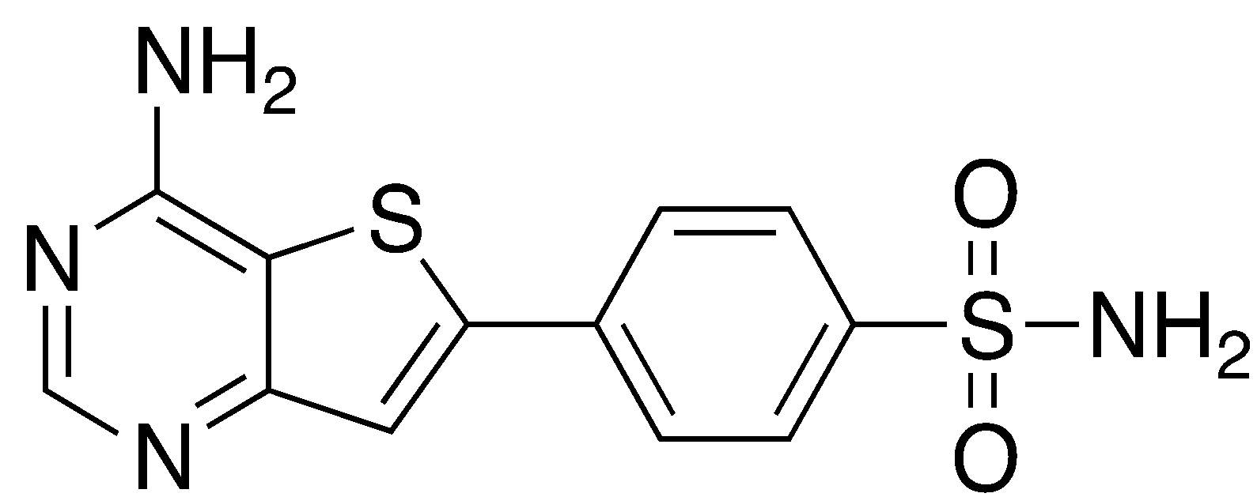

m/z (APCI+) 307.0 (100%, MH+)

**3-(4-aminothieno[3,2-d]pyrimidin-6-yl)benzenesulfonamide (AT-11)**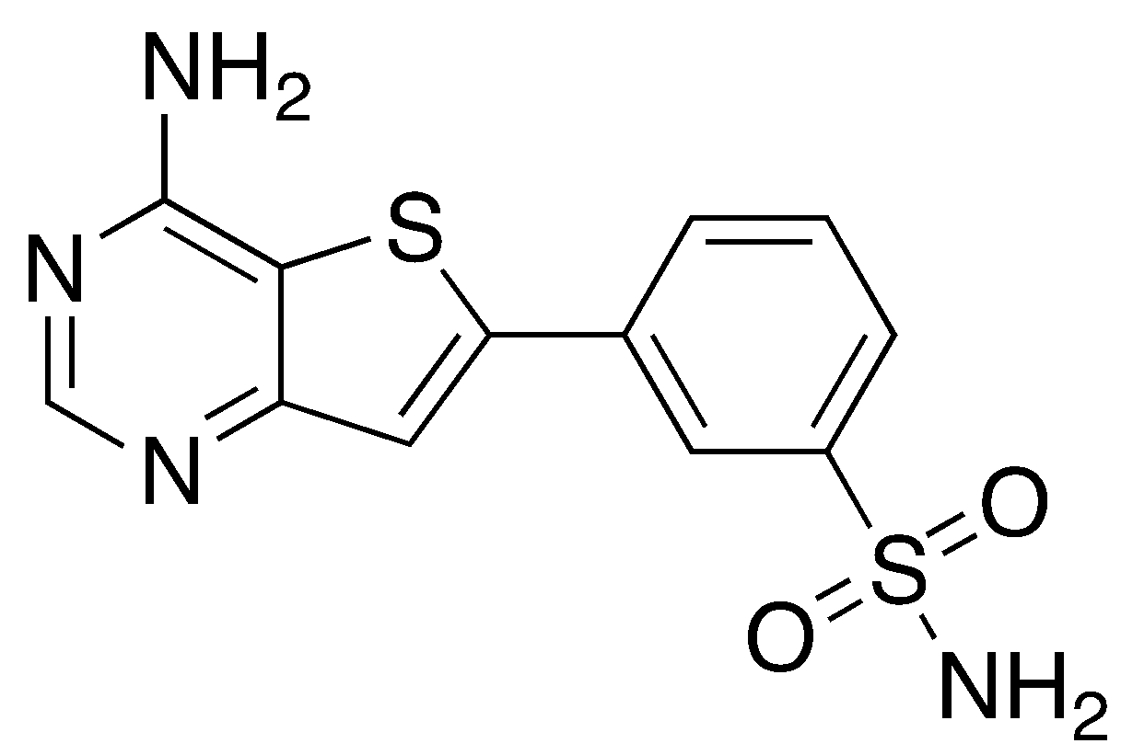

**6-(4-methoxyphenyl)thieno[3,2-d]pyrimidin-4-amine (AT-13)**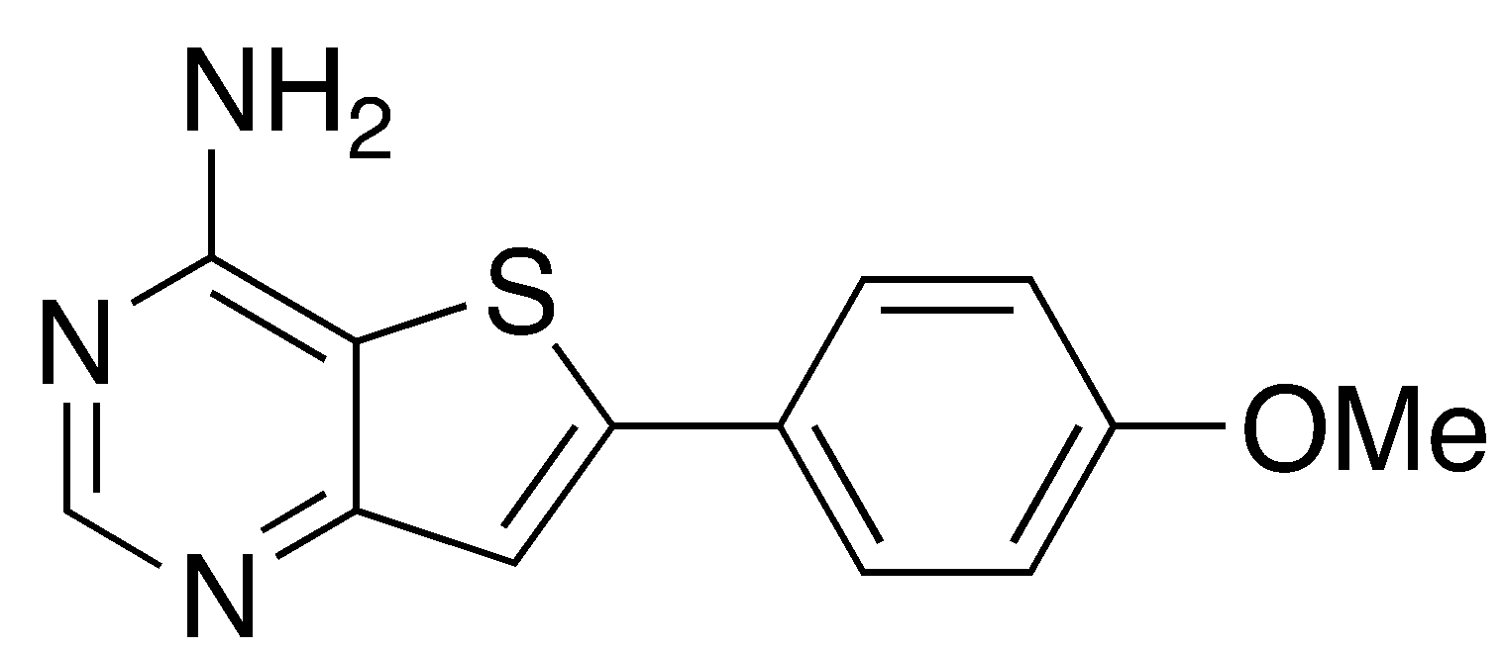

13C NMR (100 MHz, DMSO-d6): δ 55.4, 112.6, 114.7, 118.9, 125.4, 127.7, 148.9, 155.0, 157.8, 160.3, 160.7.

m/z (APCI+) 258.0 (100%, MH+).

HRMS 258.06949 (MH+) calcd. for C13H12N3OS+ (MH+) 258.06956.

**6-(4-(tert-butyl)phenyl)thieno[3,2-d]pyrimidin-4-amine (AT-14)**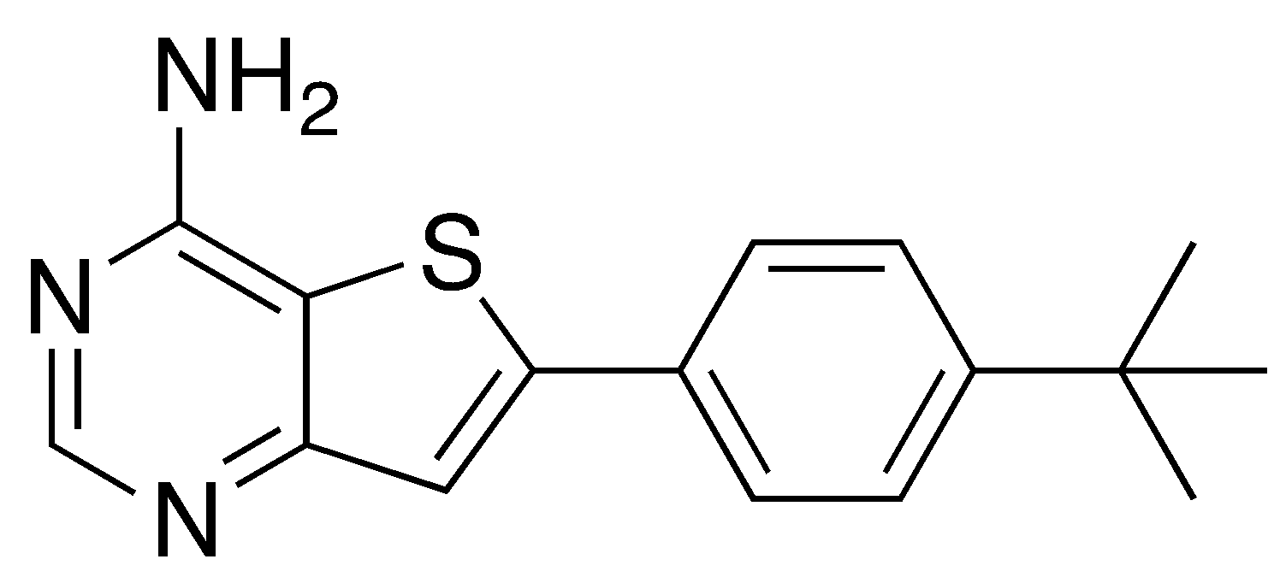

1H NMR (400 MHz, DMSO-d6): δ 1.32 (9H, s), 7.41 (1H, s), 7.51 – 7.54 (3H, m), 7.73 – 7.77 (2H, m), 8.36 (1H, s).

13C NMR (100 MHz, DMSO-d6): δ 31.4, 35.0, 126.1, 126.5, 126.6, 130.6, 149.3, 152.8, 155.6, 158.4, 161.1.

m/z (APCI+) 284.1 (100%, MH+).

HRMS 284.12156 (MH+) calcd. for C16H18N3S+ (MH+) 284.12159.

**4-(4-aminothieno[3,2-d]pyrimidin-6-yl)-N,N-dimethylbenzamide (AT-17)**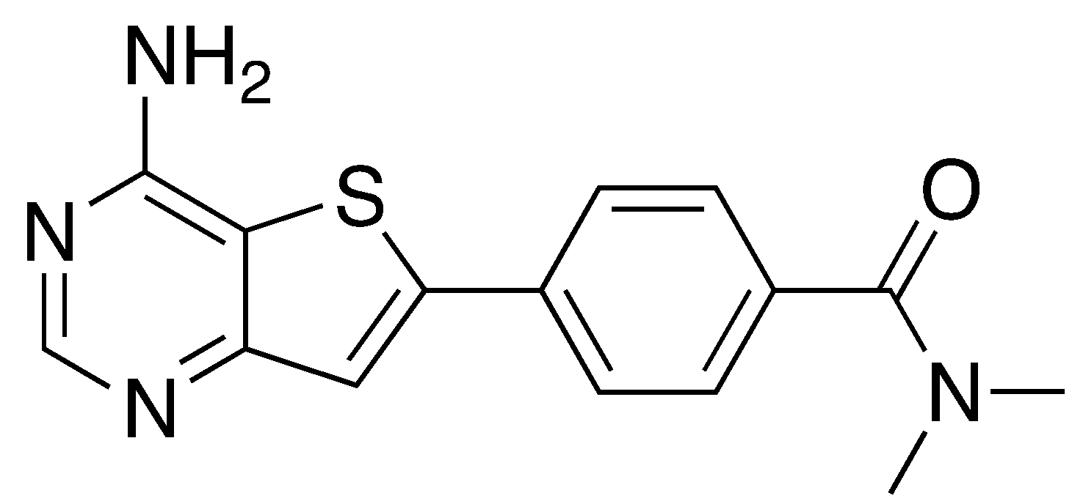

1H NMR (400 MHz, DMSO-d6): δ 3.05 (3H, s), 3.13 (3H, s), 7.56 – 7.58 (2H, m), 7.69 (1H, s), 7.91 – 7.94 (2H, m), 8.38 (1H, s).

13C NMR (100 MHz, DMSO-d6): δ 34.8, 113.6, 121.2, 126.1, 128.0, 133.6, 137.3, 147.8, 155.2, 158.0, 160.5, 169.3.

m/z (APCI+) 299.1 (100%, MH+).

HRMS 299.09618 (MH+) calcd. for C15H15N3OS+ (MH+) 299.09611.

**6-bromo-4-hydrazinylthieno[3,2-d]pyrimidine (AT-18)**

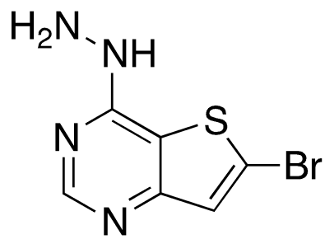

1H NMR (400 MHz, CD3OD): δ 7.32 (1H, s), 8.21 (1H, s).

m/z (APCI+) 246.9 (100%, MH+).

**(4-(4-aminothieno[3,2-d]pyrimidin-6-yl)phenyl)(morpholino)methanone (AT-19)**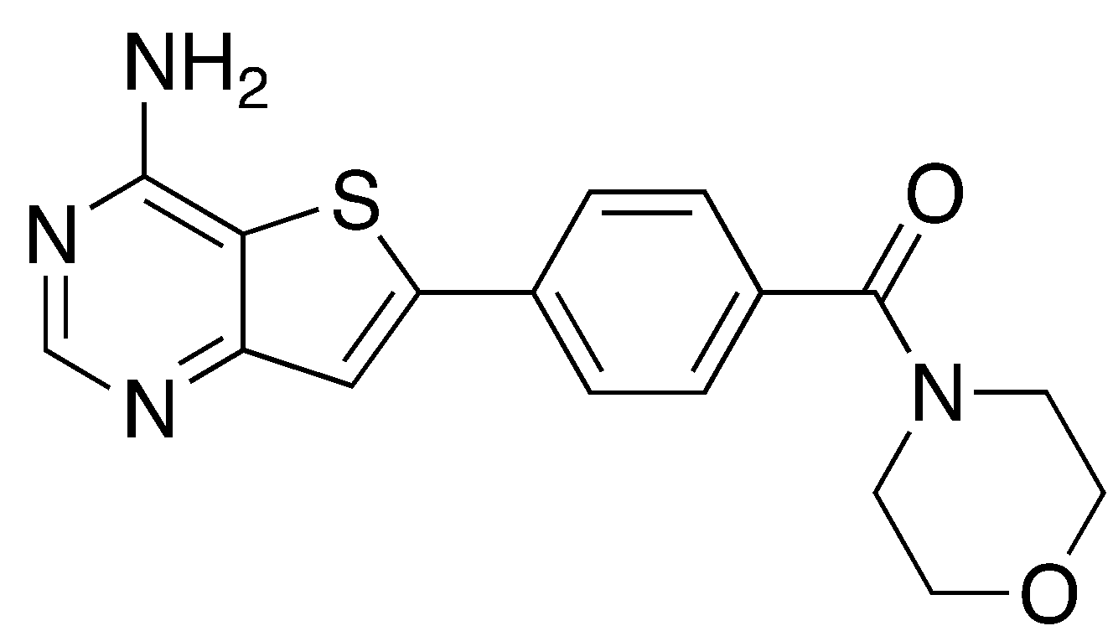

**(3-(4-aminothieno[3,2-d]pyrimidin-6-yl)phenyl)(4-methylpiperazin-1-yl)methanone (AT-20)**

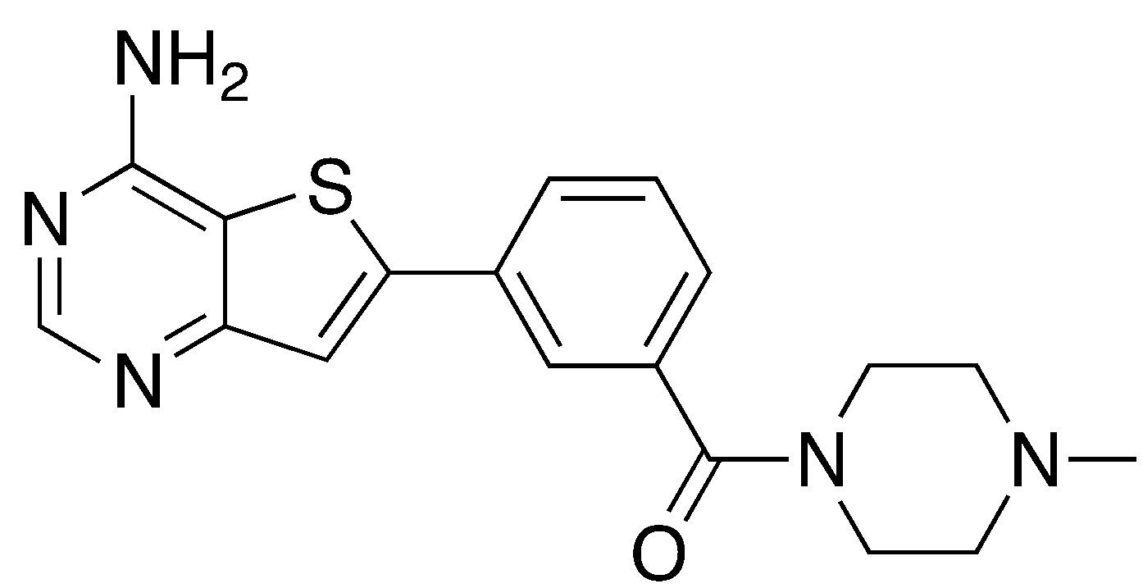

1H NMR (500 MHz, CD3OD): δ 2.34 (3H, s), 2.46 (2H, br s), 2.56 (2H, br s), 3.52 (2H, br s), 3.82 (2H, br s), 7.49 (1H, d, J 7.8), 7.59 (1H, t, J 7.8), 7.67 (1H, s), 7.86 (1H, s), 7.91 (1H, d, J 7.8), 8.37 (1H, s).

13C NMR (125 MHz, CD3OD): 45.9, 54.8, 115.8, 121.2, 126.1, 129.1 (2 signals), 130.8, 134.9, 137.9, 151.1, 155.9, 159.8, 161.0, 171.4.

**(4-(4-aminothieno[3,2-d]pyrimidin-6-yl)phenyl)(4-methylpiperazin-1-yl)methanone (AT-21)**

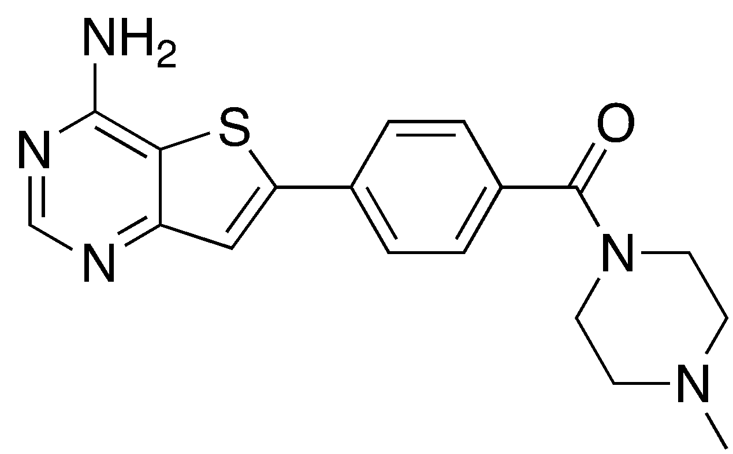

**3-(4-aminothieno[3,2-d]pyrimidin-6-yl)-N,N-dimethylbenzamide (AT-22)**

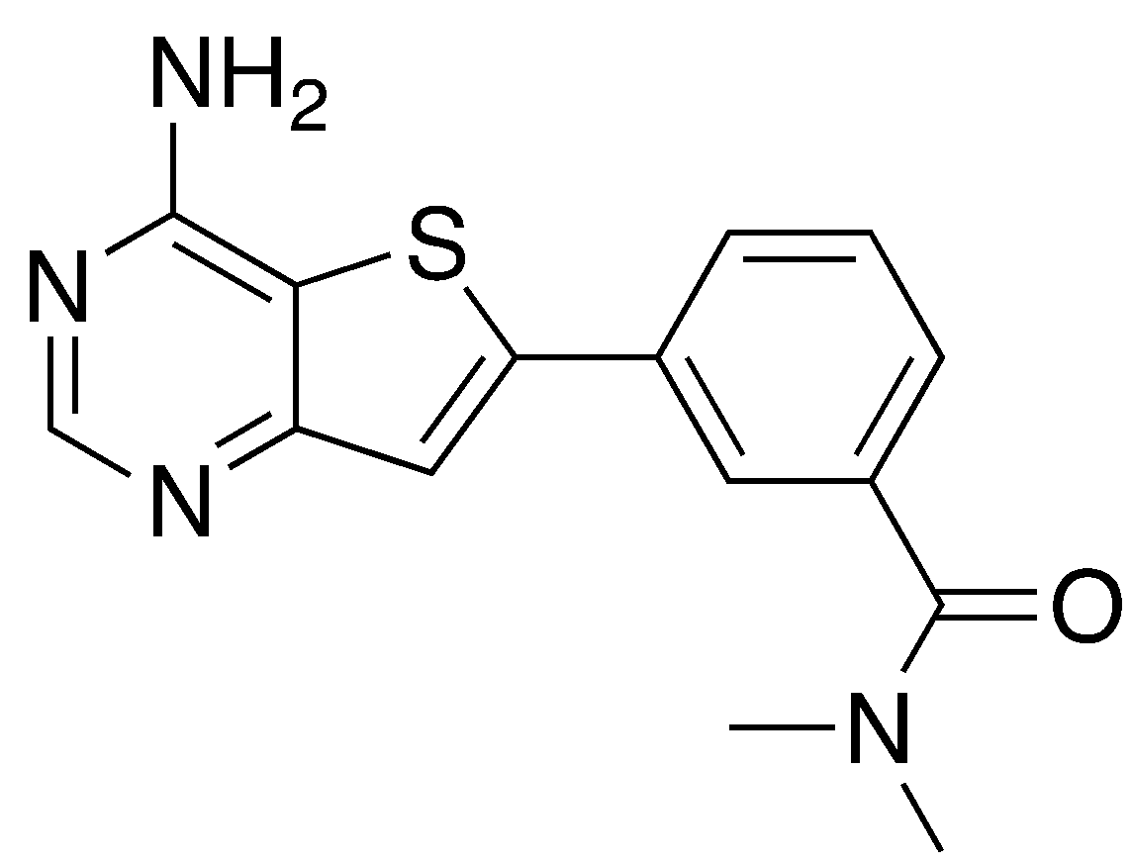

1H NMR (400 MHz, DMSO-d6): δ 2.96 (3H, s), 3.02 (3H, s), 7.48 (1H, s), 7.58 (1H, t, J 7.6), 7.84 – 7.90 (3H, m), 8.38 (1H, s).

13C NMR (100 MHz, DMSO-d6): δ 34.7, 113.5, 121.2, 124.5, 127.0, 127.8, 129.4, 132.9, 137.6, 147.9, 155.3, 158.0, 160.5, 169.3.

**4-(4-aminothieno[3,2-d]pyrimidin-6-yl)benzamide (AT-23)**

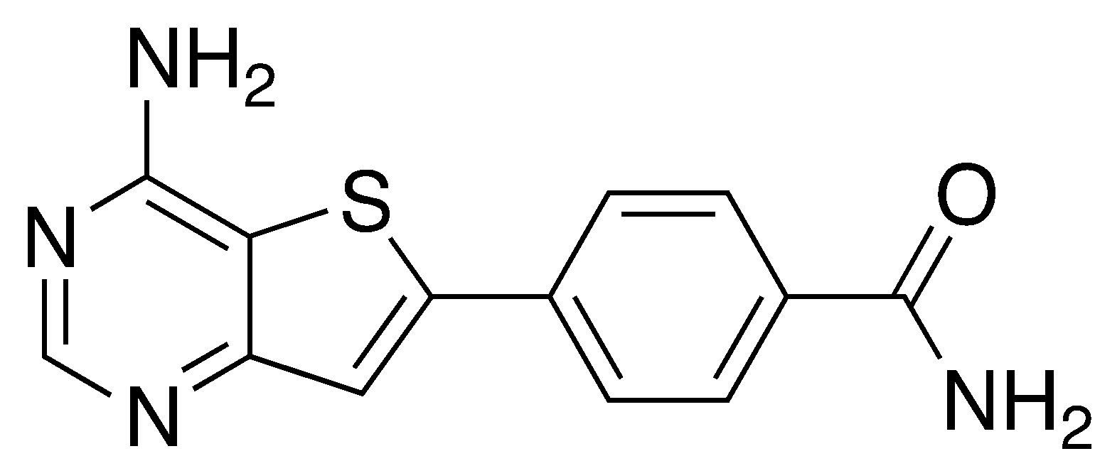

**3-(4-aminothieno[3,2-d]pyrimidin-6-yl)benzamide (AT-24)**

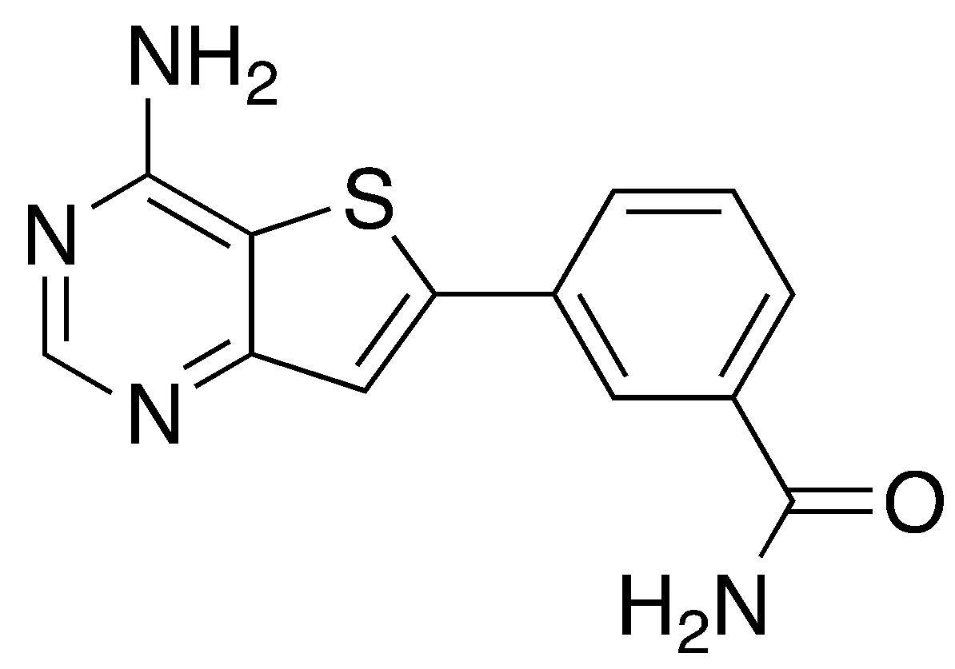

1H NMR (400 MHz, DMSO-d6/CD3OD): δ 7.68 (1H, t, J 7.8), 7.83 (1H, s), 8.04 (2H, q, J 7.8), 8.41 (1H, s), 8.47 (1H, s).

13C NMR (100 MHz, DMSO-d6/CD3OD): δ 114.9, 121.1, 126.3, 129.4, 130.1, 130.3, 134.1, 136.0, 150.3, 155.8, 159.2, 160.7, 169.6.

**General procedure CT-A**

Amine (5 equiv.) was added dropwise to 3-bromobenzenesulfonyl chloride (1 equiv.) in THF at 0°C. The reaction mixture was warmed to room temperature and stirred overnight. The mixture was diluted with water and extracted with EtOAc (x2). The organic layers were washed with brine, dried (MgSO4) and the solvent removed under reduced pressure to yield the bromosulfonamide.

**General procedure CT-B**

Bromosulfonamide (1 equiv.), KOAc (4 equiv.) and bis(pinacolato)diboron (1.5 equiv.) were dissolved in 1,4-dioxane and the mixture degassed with argon for 10 minutes at room temperature. [1,1-bis(diphenylphosphino)ferrocene]dichloropalladium(II) (0.05 equiv.) was added and the mixture was stirred at 102°C with reflux under argon overnight. The mixture was cooled to room temperature, filtered through Celite and washed with EtOAc and MeOH. The crude product was purified by flash column chromatography over silica (EtOAc/petrol) to yield the boronic ester.

**3-bromo-*N*-methylbenzenesulfonamide CT-1**

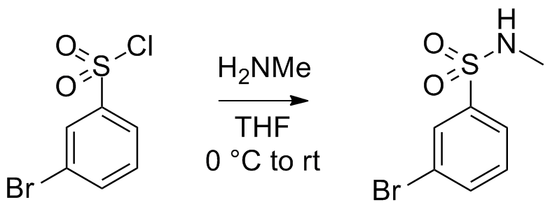

Prepared according to General Procedure CT-A from: 3-bromobenzenesulfonyl chloride (0.3 mL, 2 mmol) and methylamine (24% aq. soln., 1.4 mL, 10 mmol) in THF (3 mL) to provide the product as a pale yellow powder *(598 mg, 2.4 mmol);* **m.p. ____** ; **1H NMR** (300 MHz, CDCl3): δ 8.01 (1H, t, *J* 1.8), 7.83-7.76 (1H, m), 7.71 (1H, dq, *J* 8.0 & 0.9), 7.40 (1H, t, *J* 7.9), 4.71 (1H, bs), 2.68 (3H, d, *J* 5.0); **13C NMR** (75 MHz, CDCl­3): δ 140.80, 135.75, 130.64, 130.10, 125.71, 123.11, 29.29

*InChI* *=1S/C7H8BrNO2S/c1-9-12(10,11)7-4-2-3-6(8)5-7/h2-5,9H,1H3*

<http://malaria.ourexperiment.org/aminotpseries/8493/Synthesis_of_3BromoNmethylbenzenesulfonamide_CT_11.html>

*Lit ref*

**3-bromo*-N,N*-dimethylbenzenesulfonamide CT-4**

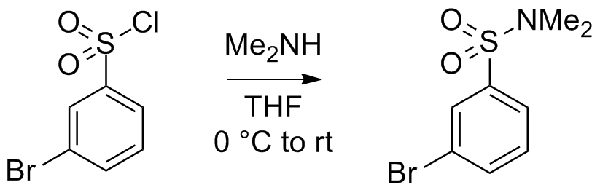

Prepared according to General Procedure CT-A from: 3-bromobenzenesulfonyl chloride (0.3 mL, 2 mmol) and dimethylamine (33% in abs. alcohol, 1.8 mL, 10 mmol) in THF (3 mL) to provide the product as a brown oil *in vacuo* which crystallised into needle-like crystals at atmospheric pressure (590 mg, 2.2 mmol); **m.p. _____; 1H NMR** (200 MHz, CDCl3): δ 7.92 (1H, bs), 7.78-7.66 (2H, m), 7.42 (1H, t, *J* 7.9), 2.73 (6H, s)

*Lit ref*

***N*-methyl-3-(4,4,5,5-tetramethyl-1,3,2-dioxaborolan-2-yl)benzenesulfonamide CT-2**

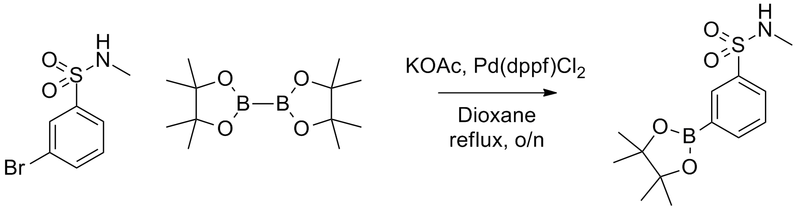

Prepared according to General Procedure CT-B from: 3-bromo-*N-*methylbenzenesulfonamide (500 mg, 2 mmol, 1 equiv.), KOAc (785 mg, 8 mmol, 4 equiv.), bis(pinacolato)diboron (762 mg, 3 mmol, 1.5 equiv.) and 1,4-dioxane (10 mL). The crude product was purified by flash column chromatography over silica (3:7 to 1:1 EtOAc/petrol) to provide the product as a white solid (414 mg, 1.4 mmol, 70%); **m.p. ____** ; **1H NMR** (300 MHz, CDCl3): δ 8.28 (1H, bs), 8.00 (1H, m), 7.94 (1H, m), 7.52 (1H, t, *J* 7.6), 4.32 (1H, d, *J* 4.8), 1.35 (1H, s)

*Lit ref*

***N,N*-dimethyl-3-(4,4,5,5-tetramethyl-1,3,2-dioxaborolan-2-yl)benzenesulfonamide CT-5**

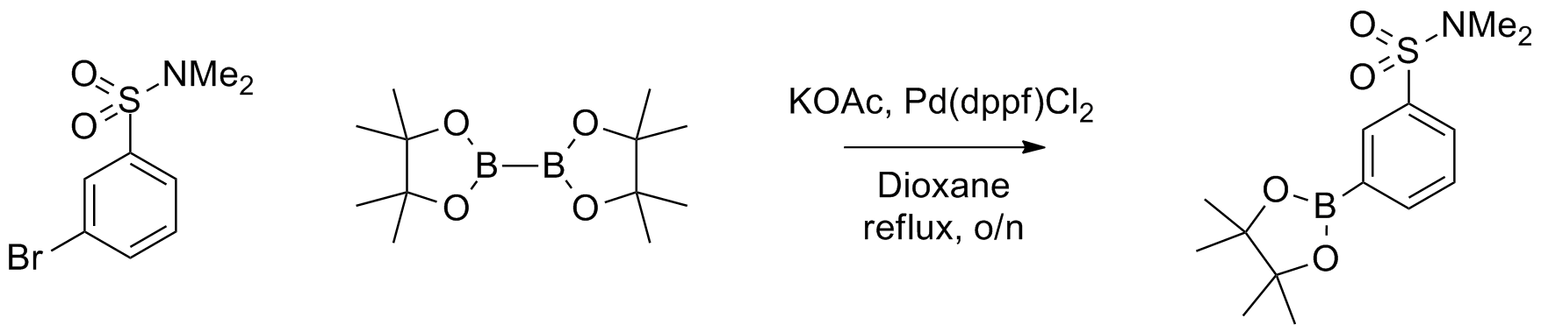

Prepared according to General Procedure CT-B from: 3-bromo-*N,N*-dimethylbenzenesulfonamide (528 mg, 2 mmol, 1 equiv.), KOAc (785 mg, 8 mmol, 4 equiv.), bis(pinacolato)diboron (762 mg, 3 mmol, 1.5 equiv.) and 1,4-dioxane (10 mL). The crude product was purified by flash column chromatography over silica (2:8 to 3:7 EtOAc/petrol) to provide the product as a white solid (   ). **m.p. ____** ; **1H NMR** (200 MHz, CDCl3): δ

*Lit ref*

**Ethyl 3-((2-ethoxy-2-oxoethyl)thio)propanoate**

To ethyl 2-mercaptoacetate (2.19 mL, 18.2 mmol, 1.0 eq) was added piperidine (0.10 mL, 1.01 mmol, 0.1 eq) with stirring. Ethyl acrylate (1.94 mL, 18.2 mmol, 1.0 equiv.) was added dropwise over 2 h. The solution was stirred at rt overnight. To the stirring solution were added additional ethyl acrylate (0.20 mL, 1.87 mmol, 0.1 equiv.) and piperidine (2 drops). The solution was stirred at rt for 6 h. To the solution were added EtOAc (30 mL) and H2O (30 mL). The organic layer was separated, washed with H2O (3 × 30 mL) and brine (30 mL), dried over MgSO4 and concd *in vacuo* to yield the title compound as a colourless, foul smelling oil (3.40 g, 17.7 mmol, 97%).



1H NMR (200 MHz, CDCl­­3): δ 1.27 (3H, t, *J* 7.2, H7), 1.29 (3H, t, *J* 7.0, H6’), 2.64 (2H, t, *J* 7.2, H3), 2.92 (2H, t, *J* 7.3, H2), 3.24 (2H, s, H2’), 4.18 (4H, apparent dt, *J* 7.4 (H5’) 7.0 (H6)). 13C NMR (100 MHz, CDCl3): δ 14.2 (C7, C6’), 27.6 (C2), 33.7 (C3), 34.4 (C2’), 60.7 (C5’), 61.7 (C6), 170.2 (C3’), 171.7 (C4). IR (oil): *v*max/cm-1 1726, 1270, 1247, 1125, 1027. LCMS (ESI+): *m/z* 221.3 ([MH]+, 100%). 1H NMR data match those reported in the literature.56

56. Duus, F., A study of the tautomerism of 2- and 4-ethoxycarbonylthiolan-3-ones implicating stereochemical effects of ring-substitution. *Tetrahedron* **1981,** *37* (15), 2633-2640.

**Methyl 3-formamidothiophene-2-carboxylate**

Methyl-3-aminothiophene-2-carboxylate (300 mg, 2.11 mmol, 1.0 eq) and NH4OAc (226 mg, 2.93 mmol, 1.4 eq) were dissolved in formic acid (1.00 mL, 26.5 mmol, 12.6 eq). The solution was heated at gentle reflux for 7 h before being allowed to cool to rt. A brown solid formed which was tipped onto ice, filtered, and washed with H2O (50 mL) to yield a pale brown powder (575 mg). The powder was dissolved in boiling 50% EtOH/H2O and filtered. The filtrate was collected and dried *in vacuo* to give the title compound as fluffy, white crystals (237 mg, 1.27 mmol, 60%).



m.p: 93 °C – 94 °C (lit: 82 °C)95. 1H NMR (300 MHz, CDCl3): δ 3.90 (3H, s, H2’), 7.49 (1H, d, *J* 5.4, H4), 8.11 (1H, d, *J* 5.4, H5), 8.42 (1H, s, H3’), 10.10 (1H, br s, Ha). LRMS (APCI): *m/z* 637.6 (3[MK]+, 10%), 607.9 (3[(M-CO)K]+, 100%), 579.9 (3[(M-2(CO))K]+, 95%), 551.9 (3[(M-3(CO))K]+, 25%. 1H NMR data match those reported in the literature.96

96. Mitchell, I. S.; Spencer, K. L.; Stengel, P.; Han, Y.; Kallan, N. C.; Munson, M.; Vigers, G. P. A.; Blake, J.; Piscopio, A.; Josey, J.; Miller, S.; Xiao, D.; Xu, R.; Rao, C.; Wang, B.; Bernacki, A. L. Akt protein kinase inhibitors for use in treatment of hyperproliferative diseases. WO2005051304A2, 2005.

**Thieno[3,2-*d*]pyrimidin-4(1*H*)-one**

*Method A.* Methyl 3-formamidothiophene-2-carboxylate (589 mg, 3.18 mmol, 1.0 eq) and ammonium formate (710 mg, 11.3 mmol, 3.5 eq) were dissolved in formamide (1.80 mL, 45.2 mmol, 14.2 eq). The slurry was heated at 140 °C for 24 h. The reaction mixture was allowed to cool to rt (40 mL). To the solution was added acetone (40 mL). The solution was concd *in vacuo* until only a little acetone remained to give a brown solution, which was left at rt for 1 h. The orange crystals that formed were collected *via* filtration and washed repeatedly with chilled H2O. The crystals were dried *in vacuo* to yield the title compound (202 mg, 1.32 mmol, 42%).



*Method B.* Methyl-3-aminothiophene-2-carboxylate **21** (2.53 g, 16.1 mmol, 1.0 eq), ammonium formate (1.10 g, 17.5 mmol, 1.1 eq) and formic acid (0.64 mL, 17.0 mmol, 1.1 eq) were dissolved in formamide (3.4 mL, 85 mmol, 5.2 eq). The slurry was heated at 140 °C for 20 h. The reaction mixture was allowed to cool to rt. Brown solid was collected *via* filtration and washed with chilled H2O. This brown powder was recrystallised from boiling 50% EtOH/H2O to give the title compound as fluffy brown crystals (1.30 g, 8.52 mmol, 53%).

m.p: 219 °C – 220 °C (lit: 220 °C). 1H NMR (200 MHz, (CD3)2SO): δ 7.42 (1H, d, *J* 5.2, H7), 8.17 (1H, s, H6), 8.20 (1H, d, *J* 5.4, H2), 12.49 (1H, br, H1). LRMS (APCI): *m/z* 153.3 ([MH]+, 100%), 185 ([MNa]+, 70%). Spectroscopic data match those reported in the literature.97

97. Orfi, L.; Waczek, F.; Pato, J.; Varga, I.; Balint, H.-B.; Houghten, R. A.; Ker, G., Improved, high yield synthesis of 3*H*-quinazolin-4-ones, the key intermediates of recently developed drugs. *Curr. Med. Chem.* **2004,** *11* (19), 2549-53.

**Thieno[3,2-*d*]pyrimidin-4-amine**

4-Chlorothieno[3,2-*d*]pyrimidine (274 mg, 1.61 mmol, 1 eq) and 28% aq NH4OH (5.0 mL, 14 M, 74 mmol, 74 eq) were heated at 120 °C for 4 h in a sealed tube. The reaction was allowed to cool to rt before MeOH (5 mL) was added. Residual solids were dissolved with shaking before the solution was concd *in vacuo* to a yellow solid, which was dissolved in boiling 80% EtOH/acetone. The solution was left undisturbed at rt for 24 h before being filtered. The filtrand was washed with chilled EtOH to yield the title compound as orange flakes (247 mg, 1.59 mmol, 94%).



m.p: 222 °C (lit95: 226 °C). 1H NMR (200 MHz, (CD3)2SO): δ 7.35 (1H, d, *J* 5.4, H7), 7.52 (2H, br s, H4’), 8.11 (1H, d, *J* 5.2, H6), 8.37 (1H, s, H2). LRMS (APCI): *m/z* 152.4 ([MH]+, 100%). Spectroscopic data match those reported in the literature.100

100. Robba, M.; Lecomte, J. M.; Sévricourt, M. C. D., Thiénopyrimidines—ii : Etude de la thiéno [3.2-*d*] pyrimidine et de quelques dérivés. *Tetrahedron* **1971,** *27* (2), 487-499.

**6-Iodothieno[3,2-*d*]pyrimidin-4(1*H*)-one**

Thieno[3,2-*d*]pyrimidin-4(1*H*)-one (1.52 g, 10.0 mmol, 1.0 equiv.) was dried *in vacuo* and dissolved in THF (75 mL) with heating and sonication. After stirring the solution at -78 °C for 10 min, *n*-BuLi solution (1.48 M in hexanes, 13.5 mL, 20.0 mmol, 2.0 equiv.) was added dropwise with stirring. The reaction was stirred at -78 °C for 1 h, allowed to warm to -40 °C, and then stirred for a further 1 h. The stirring solution was cooled to -78 °C before I2 (5.08 g, 20.0 mmol, 2 equiv.) in THF (45 mL) was added dropwise. The reaction solution was allowed to warm to rt and was then stirred at rt for a further 20 h. To the solution were added H2O (40 mL) and CHCl3 (100 mL). The biphasic solution was washed and shaken with saturated aq Na2S2O3 until the colouration disappeared. The organic layer was separated, washed with H2O (3 × 70 mL) and brine (70 mL), dried over MgSO4 and concd *in vacuo* to yield a yellow solid (925 mg). The solid was recrystallised from hot EtOH/H2O/acetone (2:2:1) to yield the title compound as pale yellow flakes (833 mg, 3.00 mmol, 30%).



Sublimes at 258 °C. Residual solid mp: 274 °C – 275 °C. 1H NMR (400 MHz, CD3OD): δ 7.59 (1H, s, H4), 8.08 (1H, s, H1). 13C-NMR (100 MHz, CD3OD): δ 89.5 (C6), 130.0 (C4a), 135.8 (C7), 138.9 (C7a), 148.0 (C2), 159.8 (C4). IR (film): *v*max/cm-1 1657, 1590. LRMS (ESI+): *m/z* 279.3 ([MH]+, 50%). HRMS (ESI+): *m/z* calcd. for [MNa]+ 300.89085, found 300.89041. Anal calcd for C6H3IN2OS: C, 25.92; H, 1.09; N, 10.07, anal calcd for C6H3IN2OS + 0.1 eq EtOH: C, 26.34; H, 1.28; N, 9.91, found: C, 26.49; H, 1.13; N, 9.95.

**4-(Thieno[3,2-*d*]pyrimidin-4-yl)morpholine**

4-Chlorothieno[3,2-*d*]pyrimidine (758 mg, 4.44 mmol, 1 equiv.) was dissolved in MeOH (20 mL) and stirred at rt. To the stirring solution was added morpholine (0.76 mL, 8.78 mmol, 1.97 equiv.) dropwise. The solution was stirred for 3 h at rt before being cooled on ice and filtered. The filtrand was washed with chilled MeOH (20 mL) and H2O (20 mL), dissolved in acetone (10 mL) and concentrated *in vacuo* to yield the title compound as a white powder (233 mg, 1.05 mmol). The filtrate was collected and concentrated *in vacuo* to yield a white gel. To the gel were added EtOAc (50 mL) and H2O (20 mL). The organic layer was separated, washed with H2O (2 × 20 mL) and brine (20 mL), dried over MgSO4 and concd *in vacuo* to give the title compound as a pale yellow powder (473 mg, 2.13 mmol) (Total yield: 706 mg, 3.18 mmol, 72%).



m.p: 135 °C – 136 °C. 1H NMR (200 MHz, CDCl3): δ 3.87 (4H, d, *J* 4.6, Ha), 4.00 (4H, d, *J* 4.8, Hb), 7.45 (1H, d, *J* 5.6, H7), 7.75 (1H, d, *J* 5.6, H6), 8.61 (1H, s, H2). 13C-NMR (75 MHz, CDCl3): δ 46.4 (Ca), 66.9 (Cb), 114.6 (C4a), 125.5 (C6), 131.7 (C7), 154.4 (C7a), 158.5 (C2), 161.8 (C4). IR (film): *v*max/cm-1 3482, 3057, 1552, 1517, 1491, 1452, 1436, 1119, 1018, 906. LRMS (ESI+): *m/z* 222.6 ([MH]+, 100%). HRMS (ESI+): *m/z* calcd. for [MH]+ 222.07011, found 222.06955. Anal calcd for C10H11N3OS: C, 54.28; H, 5.01; N, 18.99, found: C, 54.29; H, 4.96; N, 18.95.

**4-(6-Iodothieno[3,2-*d*]pyrimidin-4-yl)morpholine**

4-(Thieno[3,2-*d*]pyrimidin-4-yl)morpholine (134 mg, 0.60 mmol, 1 eq.) was dried *in vacuo* before being dissolution in THF (10 mL). The solution was stirred at -78 °C for 10 min before *n*-BuLi solution (2.5 M in hexanes, 0.40 mL, 1.00 mmol, 1.6 equiv.) was added dropwise. The solution was stirred at -78 °C for 15 min before a solution of I2 (189 mg, 0.74 mmol, 1.2 equiv.) in THF (10 mL) was added dropwise. The solution was stirred at -78 °C for 1 h, allowed to warm to rt, and stirred for 1 h. To the solution were added H2O (5 mL) and CHCl3 (50 mL). The biphasic solution was washed and shaken with saturated aq Na2S2O3 until colourisation disappeared. The organic layer was separated, washed with H2O (30 mL) and brine (30 mL), dried over MgSO4 and concd *in vacuo* to yield a yellow solid (168 mg). The solid was purified *via* column chromatography (100% hexane → 40% EtOAc/hexane) and the residue recrystallised from 50% EtOH/H2O to give the title compound as fibrous yellow needles (71 mg, 0.2 mmol, 33%).



m.p: 204 °C. 1H NMR (400 MHz, (CD3)2SO): δ 3.74 (4H, d, *J* 5.2, Ha), 3.83 (4H, d, *J* 5.2, Hb), 7.75 (1H, s, H7), 8.42 (1H, s, H2). 13C-NMR (100 MHz, (CD3)2SO): δ 45.7 (Ca), 65.9 (Cb), 90.4 (C6), 118.7 (C4), 133.8 (C7), 154.3 (C4a), 156.3 (C2), 161.9 (C7a). IR (film): *v*max/cm-1 1554, 1518, 1492, 1439. LRMS (APCI): *m/z* 348.0 ([MH]+, 60%). HRMS (ESI+): *m/z* calcd. for [MH]+ 347.96675, found 347.96625. Anal calcd for C10H10IN3OS: C, 34.60; H, 2.90; N, 12.10, anal calcd for C10H10IN3OS + 0.1 eq EtOH: C, 34.83; H, 3.04; N, 11.94, found: C, 35.19; H, 2.86; N, 12.04.

**4-(6-Bromothieno[3,2-*d*]pyrimidin-4-yl)morpholine**

4-(Thieno[3,2-*d*]pyrimidin-4-yl)morpholine (100 mg, 0.45 mmol, 1.0 eq) was dried *in vacuo* before being dissolved in THF (10 mL) and stirred at -78 °C. To the stirring solution was added ­*n*-BuLi (2.5 M in hexanes, 0.18 mL, 4.5 mmol, 9.9 eq) dropwise at -78 °C with stirring. The solution was stirred at -78 °C for 0.5 h before Br2 (0.1 mL, 1.9 mmol, 4.1 equiv.) was added dropwise at -78 °C. The solution was allowed to warm to rt before being stirred at rt overnight. To the solution were added H2O (5 mL) and EtOAc (70 mL). The biphasic solution was washed with saturated aq Na2S2O3 until colourisation disappeared. The organic layer was separated, washed with H2O (30 mL) and brine (20 mL), dried over MgSO4 and concd *in vacuo* to give an orange solid (122 mg). This solid recrystallised from boiling 50% EtOH/H2O to yield the title product as long orange rods (112 mg, 0.37 mmol, 83%).



m.p: 139 °C – 140 °C. 1H NMR (200 MHz, CDCl3): δ 3.85 (4H, d, *J* 4.4, H1’), 3.91 (4H, d, *J* 4.4, H2’), 7.46 (1H, s, H7), 8.53 (1H, s, H2).13C-NMR (75 MHz, CDCl3): δ 46.5 (C1’), 66.9 (C2’), 108.9 (C6), 123.5 (C4a), 127.9 (C7), 154.5 (C7a), 157.1 (C2), 160.8 (C4). IR (film): *v*max/cm-1 1555, 1523, 1494, 899. LRMS (APCI): *m/z* 300.0 ([MH]+, 79Br, 100%), 301.9 ([MH]+, 81Br, 99%). HRMS (ESI+): *m/z* calcd. for ([MH]+, 79Br) 299.98062, ([MH]+, 81Br) 301.97857, found 299.98003, 301.97790. Anal calcd for C10H10BrN3OS: C, 40.01; H, 3.36; N, 14.00, anal calcd for C10H10BrN3OS + 0.2 eq EtOH: C, 40.37; H, 3.65; N, 13.58, found: C, 40.67; H, 3.45; N, 13.58.

**3-(4,4,5,5-Tetramethyl-1,3,2-dioxaborolan-2-yl)benzenesulfonamide**

3-bromobenzenesulfonamide (590 mg, 2.50 mmol, 1.0 eq), dried KOAc (912 mg, 9.29 mmol, 3.7 eq) and bis(pinacolato)diboron (1.21 g, 4.78 mmol, 1.9 eq) were dissolved in 1,4-dioxane (25 mL). N2 gas was bubbled through the suspension for 1.5 h. To this degassed suspension was added PdCl2(dppf) (20.0 mg, 0.03 mmol, 1 mol %). The suspension was heated at reflux for 24 h. To the solution were added EtOAc (100 mL) and H2O (30 mL). The biphasic solution was sonicated and filtered through a pad of celite with washing by EtOAc (2 × 30 mL). The organic layer was separated, washed with brine (40 mL), dried over MgSO4 and concd *in vacuo* to yield a brown and white solid (1.36 g). This solid was purified *via* column chromatography (40% EtOAc/petrol → 100% EtOAc) and recrystallised from 50% EtOH/H2O to yield the title compound as gold flakes (435 mg, 1.54 mmol, 62%).



m.p: 222 °C – 224 °C. 1H NMR (200 MHz, CDCl3): δ 1.36 (12H, s, H9), 4.77 (2H, s, Hg), 4.94 (2H, s, H7), 7.53 (1H, t, *J* 3.7, H4), 7.93 (1H, d, *J* 7.2, H5), 8.00 (1H, d, *J* 7.8, H3), 8.28 (1H, s, H1).13C-NMR (100 MHz, CDCl3): δ 25.0 (C4’, C5’), 84.6 (C4, C5), [128.6, 129.0, 132.6, 139.1 (Cb, Cd, Ce, Cf)], 141.6 (Cc), (Ca not visible). IR (film): *v*max/cm-1 1600, 1414, 1357, 1164, 1142, 1122, 1106, 860, 840. LRMS (ESI+): *m/z* 589.0 ([2MNa]+, 55%). HRMS (ESI+): *m/z* calcd. for [MNa]+ 306.09473, found 306.09431. Anal calcd for C12H18BNO4S: C, 50.90; H, 6.41; N, 4.95, found: C, 50.87; H, 6.42; N, 4.92.

**4-(4,4,5,5-Tetramethyl-1,3,2-dioxaborolan-2-yl)benzenesulfonamide**

4-bromobenzenesulfonamide (579 mg, 2.45 mmol, 1.0 eq), dried KOAc (883 mg, 8.99 mmol, 3.7 eq) and bis(pinacolato)diboron (1.21 g, 4.76 mmol, 1.9 eq) were dissolved in 1,4-dioxane (25 mL). N2 gas was bubbled through the suspension for 1.5 h. To the degassed suspension was added PdCl2(dppf) (20.0 mg, 0.03 mmol, 1 mol %). The suspension was heated to reflux for 24 h. To the solution were added EtOAc (100 mL) and H2O (30 mL). The biphasic solution was sonicated before the solution was filtered through a pad of celite. The celite was washed with EtOAc (2 × 30 mL). The organic layer was separated, washed with brine (40 mL), dried over MgSO4 and concd *in vacuo* to yield a brown and white solid (1.27 g). The solid was purified *via* column chromatography (10% EtOAc/petrol → 75% EtOAc/petrol) and recrystallised from 75% acetone/petrol to yield the title compound as golden prisms (389 mg, 1.37 mmol, 56%).



m.p: 240 – 241 °C (lit102: 240 – 242 °C). 1H NMR (200 MHz, (CD3)2SO): δ 1.31 (12H, s, H4’, H5’), 7.41 (2H, s, Hg), 7.85 (4H, apparent s, Hb, Hc). 13C NMR (125 MHz, (CD3)2SO): δ 24.7 (C4’, C5’), 84.1 (C4, C5), 124.9 (Cc), 134.8 (Cb), 146.6 (Cd), (Ca not visible). IR (film): *v*max/cm-1 3259, 1391, 1359, 1330, 1163, 1141, 1077, 917, 856, 832. LRMS (ESI+): *m/z* 589.1 ([MNa]+, 60%). Spectral data match those reported in the literature.102

102. Boron Molecular *Boron molecular certificate of analysis*; Boron Molecular: 2012.

**Methyl 3-(2,2,2-trifluoroacetamido)thiophene-2-carboxylate**

Methyl-3-aminothiophene-2-carboxylate (1.56 g, 9.92 mmol, 1.0 eq) was dissolved in pyridine (20 mL) and MeCN (25 mL) and stirred at 0 °C for 10 min before TFAA (1.50 mL, 10.6 mmol, 1.1 eq) was added dropwise. The solution was stirred at 0°C for 2 h before being allowed to warm to rt. Volatiles were removed *in vacuo* to yield an orange liquid. To the liquid were added Et2O (50 mL) and H2O (20 mL). The organic layer was separated, washed with H2O (2 × 30 mL) and brine (30 mL), dried over MgSO4 and concd *in vacuo* to yield an orange solid (2.13 g). This solid was recrystallised with 50% EtOH/H2O to yield the title compound as yellow crystals (1.19 g 4.70 mmol, 47%).



m.p: 75 °C (lit: 76 – 77 °C). 1H NMR (300 MHz, CDCl3): δ 3.94 (3H, s, H2’), 7.57 (1H, d, *J* 5.4, H4), 8.07 (1H, d, *J* 5.4, H5). 19F-NMR (282 MHz, CDCl3): δ -75.93 . IR (film): *v*max/cm-1 1735, 1689, 1583, 1197, 1153. HRMS (ESI+): *m/z* calcd for [MNa]+ 275.99182, found 275.99127. Anal calcd for C8H6F3NO3S: C, 37.95; H, 2.39; N, 5.53, found: C, 38.22; H, 2.34; N, 5.58. Spectral data match those reported in the literature.103

103. Coutts, I. G. C.; Edwards, M.; Richards, D. J., Mild selective hydrolysis of the methyl esters of some ortho-substituted aromatic carboxylic acids. *Synthesis* **1981,** *13*, 487-9.

***tert*-Butyl (3-(4,4,5,5-tetramethyl-1,3,2-dioxaborolan-2-yl)phenyl)sulfonylcarbamate (48)**

3-(4,4,5,5-Tetramethyl-1,3,2-dioxaborolan-2-yl)benzenesulfondamide **41** (142 mg, 0.50X mmol, 1.0 eq) and *Boc*2O (103 mg, 0.47X mmol, 0.9 eq), DMAP (10.0 mg, 0.08XX mmol, 0.2 eq) and Et3N (0.08 mL, 0.57 mmol, 1.1 eq) were dissolved in CH2Cl2 (10 mL) and stirred at rt for 24 h. To the solution were added EtOAc (50 mL) and H2O (50 mL). The organic layer was separated, washed with H2O (2 × 30 mL) and brine (20 mL), dried over MgSO4 and concentrated *in vacuo* to yield a yellow oil (119 mg) that was purified with column chromatography (EtOAc 10% to MeOH/CH2Cl2) to give the product as a yellow oil (77.0 mg, 0.20X mmol, 40%).



**1H NMR** (200 MHz, CDCl3): δ 1.25 (9H, s, Hj), 1.35 (12H, s, H4’, H5’), 7.54 (1H, t, *J* 7.6, He), 8.05 (1H, d, *J* 7.4, Hf), 8.10 (1H, d, *J* 8.0, Hd), 8.42 (1H, s, Hb); **13C-NMR** (100 MHz, CDCl3): δ 25.0 (C4’, C5’), 28.0 (Cj), 84.1 (Ci), 84.6 (C4, C5), [128.3, 130.9, 134.2, 139.8 (Cb, Cd, Ce, Cf)], 138.9 (Cc), 149.6 (Ch), (Ca not visible); **IR** (oil) *v*max/cm-1 1746, 1357, 1143, 1088, 842; **LRMS** (ESI+) *m/z* 405.9 ([MNa]+, 20%), 788.8 ([2MNa]+, 100%); **HRMS** (ESI+) *m/z* calcd. for [MNa]+ 406.14716, found 406.14692.

InChI needed here.

Link to ELN needed here.